Question 1: Play with repl while running commands and operators.

Question 2: Given a no print its remainder. Which command will you use ?

A=10

B=20

A%B (%is the command for remainder)

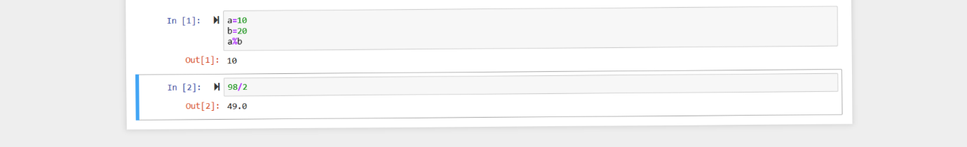

Question 3: Experiment with str concatenation.

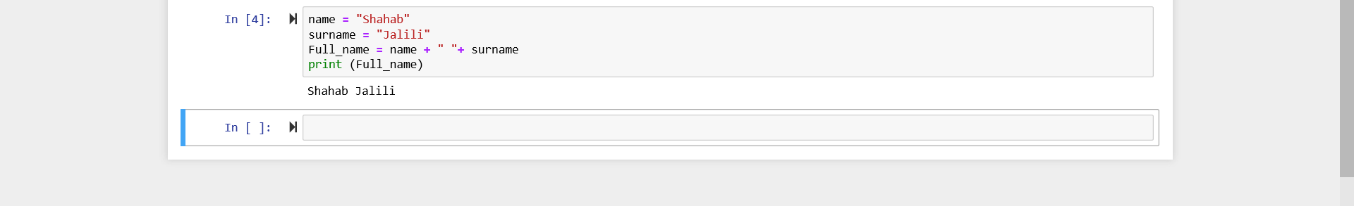

Question 4: try naming some variables and see what all variables names throws error . Question 5: Explore more on the things we learned in the class.